1. **What is the difference between Series and DataFrames?**

**Series**: A one-dimensional labeled array capable of holding any data type. It is like a column in a table. It can hold data such as integers, strings, floating point numbers, Python objects, etc.

**DataFrame**: A two-dimensional, size-mutable, potentially heterogeneous tabular data structure with labeled axes (rows and columns). It is similar to a table in a database or an Excel spreadsheet.

1. **Create a database name Travel_Planner in mysql ,and create a table name bookings in that which having attributes (user_id INT, fligh_id INT,hoel_id INT, aciviy_id INT,booking_dae DATE) .fill with some dummy value .Now you have to read the content of this table using pandas as dataframe.Show the output.**

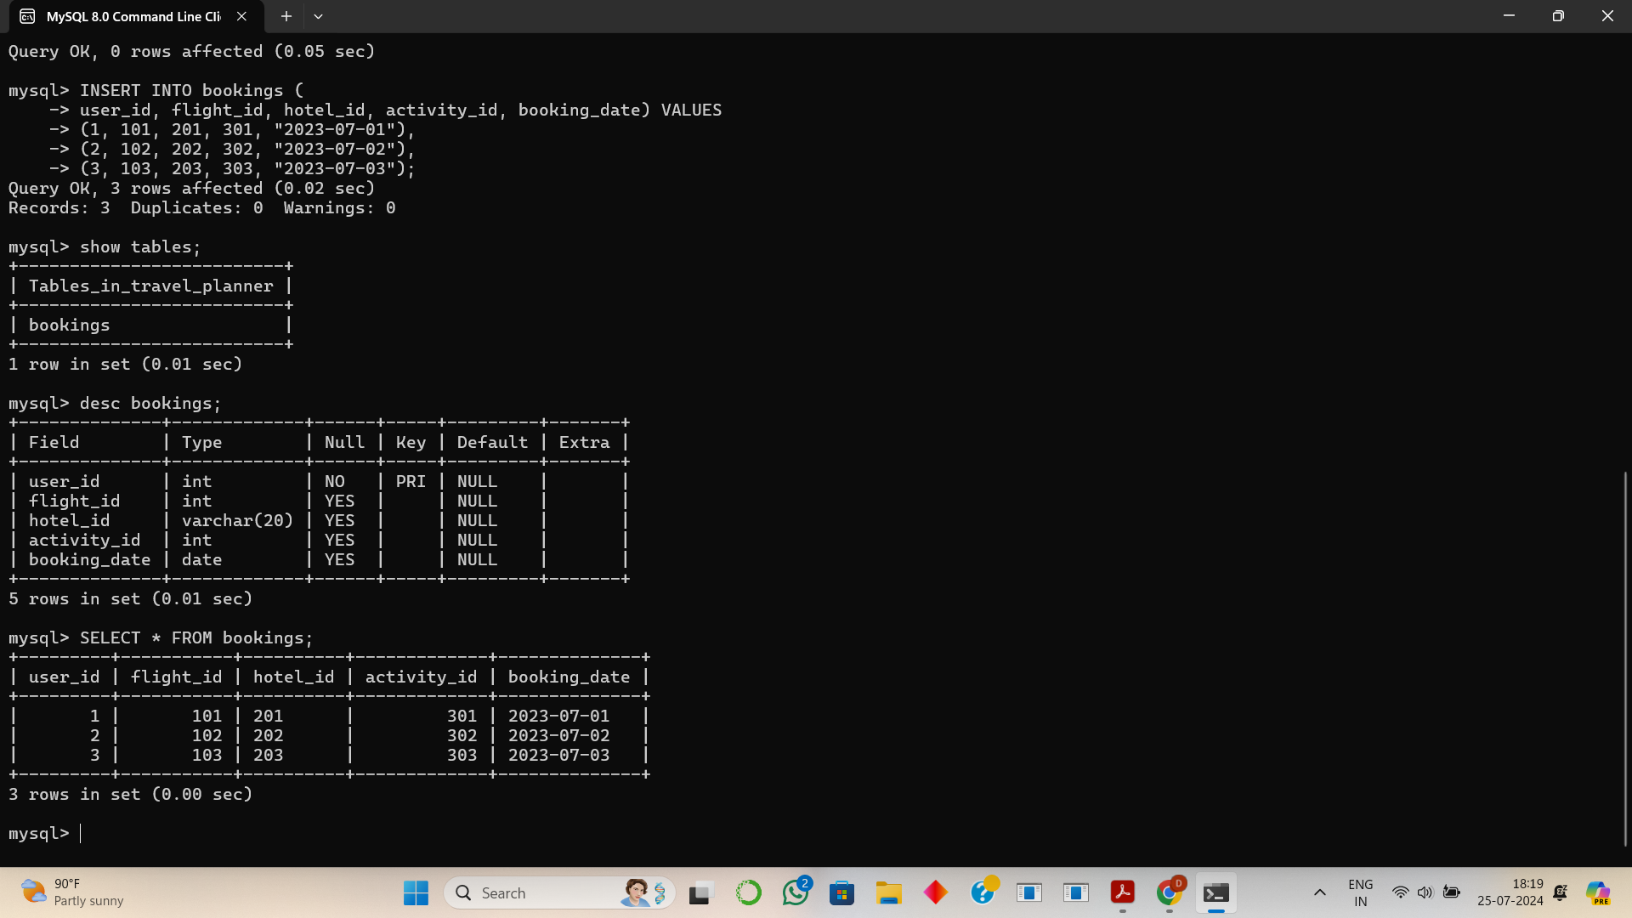

1. **Difference between loc and iloc.**

**loc**: Access a group of rows and columns by labels or a boolean array. loc is label-based, which means that you have to specify the name of the rows and columns that you need to filter out.

**iloc**: Access a group of rows and columns by integer position(s). iloc is integer-based, which means you have to specify rows and columns by their integer index.

1. **Difference between supervised and unsupervised learning.**

Supervised Learning: The model is trained on a labeled dataset, which means that each training example is paired with an output label. Examples include classification and regression.

Unsupervised Learning: The model is trained on unlabeled data and is supposed to find patterns and structure in the data. Examples include clustering and association.

1. **Explain bias-variance trade off.**

The bias-variance tradeoff is the balance between two sources of error that affect the performance of machine learning algorithms:

* **Bias**: Error due to overly simplistic assumptions in the learning algorithm. High bias can cause underfitting.
* **Variance**: Error due to too much complexity in the learning algorithm. High variance can cause overfitting.

The goal is to find a balance where both bias and variance are minimized to ensure good performance on both training and test data.

1. **What are precision and recall? How are they different from accuracy?**

**Precision**: The ratio of true positive results to the total predicted positives.

**Recall**: The ratio of true positive results to the total actual positives.

**Accuracy**: The ratio of correctly predicted instances to the total instances.

1. **What is overfitting and how can it be prevented?**

**Overfitting**: A modeling error that occurs when a function is too closely aligned to a limited set of data points, causing it to capture noise along with the underlying pattern.

**Prevention Methods**:

* 1. Use more training data
  2. Employ cross-validation techniques
  3. Prune the model
  4. Use regularization techniques like L1 (Lasso) and L2 (Ridge)
  5. Simplify the model
  6. Ensemble methods like bagging and boosting

1. **Explain the concept of cross validation.**

Cross-validation is a technique used to evaluate the performance of a machine learning model by splitting the dataset into multiple training and testing sets. It helps in assessing how the model will generalize to an independent dataset. The most common method is k-fold cross-validation, where the data is divided into k subsets, and the model is trained and validated k times, each time using a different subset as the validation set and the remaining k-1 subsets as the training set.

1. **Difference between classification and regression problem.**

Classification: A type of problem where the output variable is a category or class label. Examples include spam detection, image recognition, and disease diagnosis.

Regression: A type of problem where the output variable is a continuous value. Examples include predicting house prices, stock prices, and temperature.

1. **Explain the concept of ensemble learning.**

Ensemble learning is a technique where multiple machine learning models are combined to achieve better performance than any single model. It can be done using methods like bagging, boosting, and stacking. The idea is to leverage the strengths and mitigate the weaknesses of different models.

1. **What is gradient descent and how does it work?**

Gradient descent is an optimization algorithm used to minimize the cost function in machine learning models. It works by iteratively adjusting the model parameters in the direction of the negative gradient of the cost function.

* **Batch Gradient Descent**: Uses the entire dataset to compute the gradient of the cost function.
* **Stochastic Gradient Descent (SGD)**: Uses a single training example to compute the gradient, which makes it faster but noisier.

1. **Difference between batch gradient descent and stochastic gradient descent.**

Batch Gradient Descent: Uses the entire dataset to compute the gradient of the cost function.

Stochastic Gradient Descent (SGD): Uses a single training example to compute the gradient, which makes it faster but noisier.

1. **What is the curse of dimensionality in machine learning?**

The curse of dimensionality refers to various problems that arise when analyzing and organizing data in high-dimensional spaces. As the number of dimensions increases, the volume of the space increases exponentially, making the available data sparse. This sparsity makes it difficult for algorithms to find patterns and can lead to overfitting.

1. **Difference between L1 and L2 regularization.**

**L1 Regularization (Lasso)**: Adds the absolute value of the coefficients as a penalty term to the loss function. It can lead to sparse models where some feature weights are exactly zero.  
Loss Function=Loss+λ∑i∣w|

**L2 Regularization (Ridge)**: Adds the squared value of the coefficients as a penalty term to the loss function. It tends to distribute the error among all weights.  
Loss_fns = Loss + lambda*(w^2)

1. **What is confusion matrix and how is it used?**

A confusion matrix is a table used to evaluate the performance of a classification model. It shows the counts of true positives, false positives, true negatives, and false negatives.

1. **Define AUC-ROC curve.**

The AUC-ROC curve is a graphical representation of a classification model's performance. The ROC curve plots the true positive rate (recall) against the false positive rate, while the AUC (Area Under the Curve) represents the probability that the model ranks a random positive example higher than a random negative example.

1. **Explain the K-nearest-neighbors algorithms.**

k-Nearest Neighbors (k-NN) is a non-parametric classification algorithm that classifies a data point based on the majority class of its k nearest neighbors. The distance metric, like Euclidean distance, is used to find the neighbors.

1. **Explain the basic concept of SVM.**

A Support Vector Machine (SVM) is a supervised learning algorithm used for classification and regression. It works by finding the hyperplane that best separates the classes in the feature space.

* **Kernel Trick**: Allows SVM to handle non-linearly separable data by transforming the input space into a higher-dimensional space using kernel functions like linear, polynomial, and RBF (Radial Basis Function).
* **Hyperplane**: The decision boundary that separates the different classes in SVM. It is determined by maximizing the margin between the closest points of the classes (support vectors).
* **Hard Margin vs. Soft Margin**: Hard margin SVM strictly separates the classes without any errors, while soft margin SVM allows some misclassifications to handle noisy data.

1. **How does the kernel trick work in SVM?**

Allows SVM to handle non-linearly separable data by transforming the input space into a higher-dimensional space using kernel functions like linear, polynomial, and RBF (Radial Basis Function).

1. **Different types of kernels used in SVM and when would you use each?**

#### **1. Linear Kernel:** The linear kernel is used when the data is linearly separable, meaning you can draw a straight line (or hyperplane in higher dimensions) to separate the classes. **When to Use**: When the data is linearly separable and When the number of features is greater than the number of observations.

#### **Mathematical Representation**: K(x,y)=x⋅yK(x, y) = x \cdot yK(x,y)=x⋅y

**2. Polynomial kernel:** is used when the data is not linearly separable and has interactions between features. **When to Use**: When you expect the relationship between features to be polynomial and When the data is not linearly separable.

**Mathematical Representation**: K(x,y)=(x⋅y+c)dK(x, y) = (x \cdot y + c)^dK(x,y)=(x⋅y+c)d Where c is a constant and d is the degree of the polynomial.

**3. Radial Basis Function (RBF) Kernel:** The RBF kernel is a popular choice for non-linear data. It can handle the complexity by transforming the data into a higher-dimensional space. When to Use: When the data is not linearly separable and When the decision boundary is highly non-linear.

Mathematical Representation: K(x,y)=exp⁡(−γ∥x−y∥2)

1. **What is the hyperplane in SVM and how is it determined?**

The hyperplane in SVM is the decision boundary that separates different classes in the feature space. It is determined by maximizing the margin between the closest points of the classes (support vectors). The equation of the hyperplane in a 2D space is: w⋅x+b=0 where w is the weight vector, x is the feature vector, and b is the bias.

1. **Pros and cons of using SVM.**

**Pros:**

**Effective in high-dimensional spaces**: SVM is effective when the number of dimensions exceeds the number of samples.

**Memory efficient**: Uses a subset of training points (support vectors) in the decision function.

**Versatile**: Different kernel functions can be specified for the decision function.

**Cons:**

**Not suitable for large datasets**: Training time can be high.

**Not effective when the data is noisy**: SVM does not perform well when the data has a lot of overlapping classes.

**Choice of kernel**: The right choice of kernel is crucial.

1. **Explain the difference between a hard margin and a soft margin?**

**Hard Margin SVM**: Assumes that the data is linearly separable and finds a hyperplane that perfectly separates the classes. It does not allow for any misclassifications.  
**Pros**: Provides a clear margin of separation. **Cons**: Not robust to outliers or noisy data.

**Soft Margin SVM**: Allows for some misclassifications to create a better generalization for the model. It introduces a slack variable to penalize misclassifications.  
**Pros**: More robust to noisy data and outliers. **Cons**: Requires tuning of the penalty parameter CCC.

1. **Process of constructing a decision tree.**

**Select the best feature**: Use criteria like Information Gain or Gini Impurity.

**Split the dataset**: Create branches based on the selected feature.

**Repeat recursively**: Apply the process to the subsets until stopping criteria are met (e.g., maximum depth, minimum samples per leaf).

**Leaf nodes**: Assign a class label based on the majority class of the subset.

1. **Working principle of a decision tree.**

**Root Node**: Start with the entire dataset and select the best feature to split the data.

**Internal Nodes**: Each node represents a feature in the dataset, and each branch represents a decision rule.

**Leaf Nodes**: Represent the outcome or class label.

1. **What is information gain and how is it used in decision trees?**

Information Gain measures the reduction in entropy or impurity after a dataset is split on an attribute. It helps in selecting the attribute that best separates the data.

1. **Explain Gini impurity and its role in decision trees.**

Gini Impurity measures the probability of a randomly chosen element being incorrectly classified. It is used to select the best splits in decision trees.

Gini Impurity=1−∑(p^2)

1. **Advantages and disadvantages of decision trees.**

**Advantages:**

* **Easy to interpret**: Visual representation is intuitive.
* **Handles both numerical and categorical data**.
* **Requires little data preprocessing**: No need for scaling or normalization.

**Disadvantages:**

**Prone to overfitting**: Can create complex trees that do not generalize well.

**Sensitive to noisy data**: Minor changes in data can result in different splits.

1. **How do random forests improve upon decision trees.**

Random forests improve upon decision trees by creating an ensemble of trees and aggregating their results. This reduces overfitting and improves generalization.

1. **How does random forest algorithm work?**

**Bootstrapping**: Create multiple subsets of the training data by sampling with replacement.

**Tree Construction**: Build a decision tree on each subset.

**Aggregation**: Combine the predictions of all trees by averaging (regression) or voting (classification).

1. **What is bootstrapping in the context of random forests?**

Bootstrapping involves sampling the training data with replacement to create multiple datasets. This technique helps in reducing variance and improves the robustness of the model.

1. **Explain the concept of feature importance in random forests.**

Feature importance measures the contribution of each feature to the model's predictions. It is determined by the reduction in impurity (e.g., Gini Impurity) attributed to each feature.

1. **What are the key hyperparameters of a random forest and how do they affect the model?**

**Number of Trees (n_estimators)**: More trees reduce variance but increase computation time.

**Maximum Depth (max_depth)**: Limits the depth of each tree to prevent overfitting.

**Minimum Samples Split (min_samples_split)**: The minimum number of samples required to split a node.

**Number of Features (max_features)**: The number of features to consider when looking for the best split.

1. **Describe the logistic regression model and its assumptions.**

Logistic regression is a linear model used for binary classification problems. It assumes a linear relationship between the input features and the log-odds of the outcome.

1. **What is the sigmoid function and how is it used in logistic regression?**

The sigmoid function maps any real-valued number into a value between 0 and 1, which represents a probability. Logistic regression handles binary classification by modeling the probability that an instance belongs to a particular class using the logistic (sigmoid) function.

1. **Explain the concept of cost function in logistic regression.**

The cost function measures the difference between the predicted probabilities and the actual labels. It is minimized during training to find the best-fitting parameters.

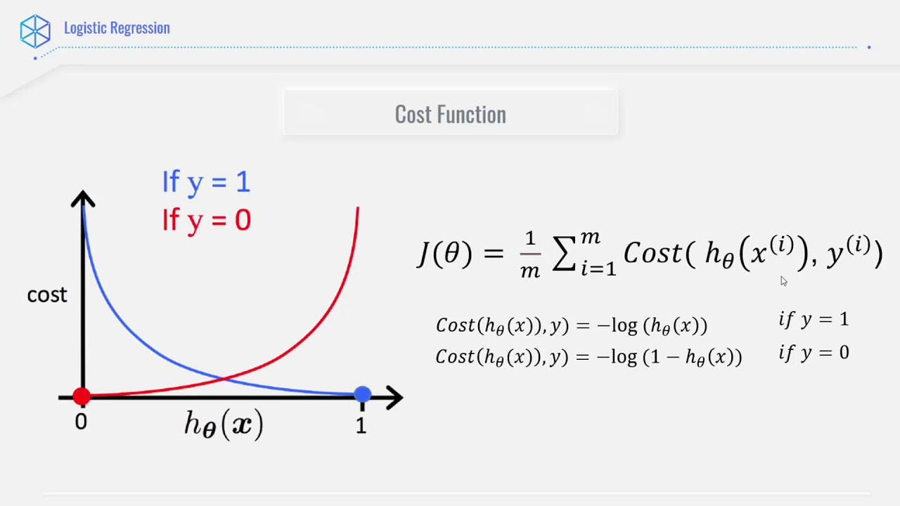

1. **How can logistic regression be extended to handle multiclass classification?**

Logistic regression can be extended to multiclass classification using techniques like one-vs-rest (OvR) and one-vs-one (OvO).

1. **Difference between L1 and L2 regularization in logistic regression.**

**L1 Regularization (Lasso):**

* Adds the absolute value of the magnitude of coefficients as a penalty term to the loss function.
* Encourages sparsity in the model (i.e., some coefficients become exactly zero), which is useful for feature selection.  
  Loss Function=Loss+λ∑i∣wi∣

**L2 Regularization (Ridge):**

Adds the squared magnitude of coefficients as a penalty term to the loss function.

Tends to distribute the error among all the weights and prevents large weights, thus reducing overfitting.  
Loss Function=Loss+λ∑|w^2|

1. **What is XGBoost and how does it differ from other boosting algorithms?**

**XGBoost (Extreme Gradient Boosting):**

* An advanced implementation of gradient boosting designed for speed and performance.
* Handles missing values internally.
* Supports parallel processing.
* Implements regularization to reduce overfitting.
* Provides extensive hyperparameter tuning.

**Differences from Other Boosting Algorithms:**

**Speed and Performance**: Optimized for parallel processing and efficient memory usage.

**Regularization**: Includes both L1 (Lasso) and L2 (Ridge) regularization to prevent overfitting.

**Handling Missing Values**: Automatically handles missing values by learning which direction to take in the tree when a value is missing.

1. **Explain the concept of boosting in the context of ensemble learning.**

Boosting is an ensemble technique that combines multiple weak learners (typically decision trees) to create a strong learner. Each new model corrects the errors of the previous models by focusing on the misclassified instances. The final model is a weighted sum of all the weak models.

1. **How does XGBoost handle missing values?**

XGBoost handles missing values by automatically learning the best way to handle them during training. When a value is missing, XGBoost splits the data into two branches: one for instances with the value present and one for instances with the value missing. It then learns the best path for the missing values to take.

1. **What are the key hyperparameters in XGBoost and how do they affect the model performance?**

**n_estimators**: Number of boosting rounds.

* **Effect**: More rounds can lead to better performance but increase the risk of overfitting.

**learning_rate**: Step size shrinkage used to prevent overfitting.

* **Effect**: Lower values make the model more robust to overfitting but require more boosting rounds.

**max_depth**: Maximum depth of the trees.

* **Effect**: Larger values can capture more complex patterns but increase the risk of overfitting.

**min_child_weight**: Minimum sum of instance weight needed in a child.

* **Effect**: Higher values prevent the model from learning relations which might be highly specific to the particular sample selected for a tree.

**subsample**: Fraction of samples used for training each tree.

* **Effect**: Reducing it prevents overfitting but too small values might lead to underfitting.

**colsample_bytree**: Fraction of features used for training each tree.

**Effect**: Like subsample but for features, helps to prevent overfitting.

1. **Describe the process of Gradient boosting in XGBoost.**

**Initialize** the model with a base prediction (e.g., the mean of the target values).

**Compute the residuals** (difference between actual and predicted values).

**Train a weak learner** (e.g., a small decision tree) to predict the residuals.

**Add the weak learner** to the model to improve predictions.

**Update the residuals** based on the new predictions.

**Repeat** steps 3-5 for a specified number of iterations (n_estimators).

1. **What are the advantages and disadvantages of using XGBoost?**

**Advantages:**

* **High Performance**: Optimized for speed and efficiency.
* **Regularization**: Reduces overfitting and improves generalization.
* **Handles Missing Data**: Automatically deals with missing values.
* **Parallel Processing**: Utilizes multiple cores for faster training.
* **Feature Importance**: Provides insights into feature importance.

**Disadvantages:**

* **Complexity**: Requires careful tuning of hyperparameters.
* **Memory Consumption**: Can consume a lot of memory for large datasets.
* **Sensitivity to Noise**: Can be sensitive to noisy data if not properly tuned.